Share Site and User Statistics Dashlet

Version | Date | Authors | Description
.01 | Aug 26, 2011 | Amita Bhandari | workflow and site Statistics dashlet



Table Of Content

Overview 3
Requirement Details 3
Usability 3
Features of Dashlet 3
Hardware And Software Specification 4
Installation Steps: 4
• Workflow Statistics Dashlet: 4
• Site Statistics Dashlet: 4
Build From Source 5
Screen Shot of the Worflow Dashlet 5
Screen Shot of the Site Statistics Dashlet 6

Overview

This document details the requirement , usability , features of Site and user Statistics dashlet, Hardware and Software Specifications and Files deployed .

Requirement Details

The site dashlet provides statistical information about No. Of Documents, wiki, blogs, forums for a specific site for either all users or a particular user in graphical view. In
addition to that, there is User dashlet, which will display information about active workflows and completed workflows for any user. The records can show for a current year, any year or range of years.

Usability

The dashlet will be helpful for various reasons.
- If an organization has multiple sites deployed, and the administrator group (it can be a group of top management people) wants to get information about the activities going in each site. The site dashlet is going to provide a graphical view of the site data. The User dashlet will detail about any users task. With this information the organization can get which site is more involved in collaboration. With the no. of documents, blogs, forums etc. one can know about the contribution for each site. Also can know about the status of each user’s tasks.
- If the organization wants to know about the progress of site every year or any year in terms of activities, can make use of this dashlet.
- Any logged in user, can check the status of other user with respect to their tasks. This is good to know especially for Project Managers and Team Leads.

Features of Dashlet
- Yearly graphical view of document, wiki, blog, posts for all or specific user.
- Current Year graphical view of document, wiki, blog, posts for all or specific user.
- Tasks wise graphical report for a specific user

Hardware And Software Specification

This dashlet is tested on windows XP machine. This is compatible…. It is compatible to Internet Explorer 8 and Mozilla FireFox 3.5. Softwares used are mentioned below:

Software | Versions
Alfresco Share | Alfresco 3.4.2
JDK | 1.6
PostgresSql | 9.0
Flash Player 9.0.45 or higher. | 9.0.45

Installation Steps:

Workflow Statistics Dashlet:

The dashlet is packaged as a single JAR file for easy installation into Alfresco Share.
To install the component, drop the workflow-statistics.jar file into the following two
directories within your Alfresco installation, and restart the application server.

tomcat/webapps/alfresco/WEB-INF/lib
tomcat/webapps/share/WEB-INF/lib

Once you have run this you will need to restart Tomcat so that the classpath resources in the JAR file are picked up.

Site Statistics Dashlet:

The dashlet is packaged as a single JAR file for easy installation into Alfresco Share.
To install the component, drop the site-statistics.jar file into the following two
directories within your Alfresco installation, and restart the application server.

tomcat/webapps/alfresco/WEB-INF/lib
tomcat/webapps/share/WEB-INF/lib

Once you have run this you will need to restart Tomcat so that the classpath resources in the JAR file are picked up.

Downloaded Path

One can download the source code from https://site-statistics.googlecode.com/svn/trunk/

Build From Source

To build the JAR file, run the following command from the base project
directory.

ant dist-jar

The command should build a JAR file named workflow-statistics.jar
in the 'dist' directory within your project/build folder.

Screen Shot of the Worflow Dashlet

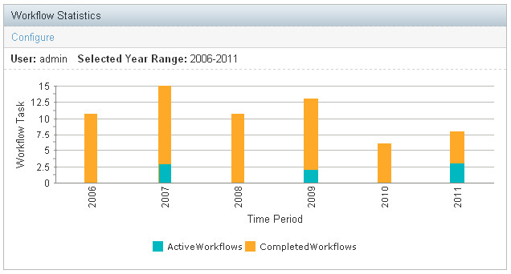

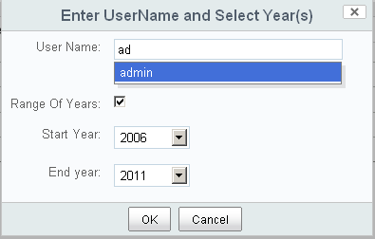

Screen Shot of the Site Statistics Dashlet

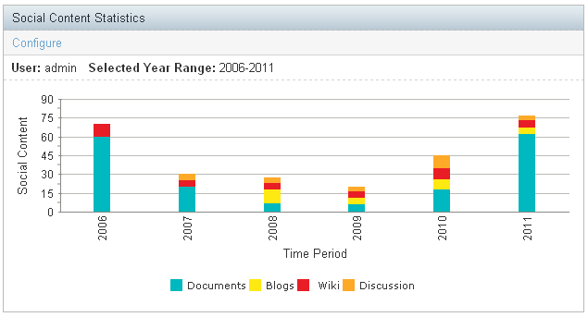

NOTE: For best view it should be placed in the center of dashboard.

For Detail information please refer Readme.txt for each project

